**VINAYA SV**

**727721EUIT178**

**DAY 5 SELENIUM WEB HANDLERS**

**Class Exercise 1:**

| **package com.Day5.Day5CE; import org.openqa.selenium.By; import org.openqa.selenium.WebDriver; import org.openqa.selenium.WebElement; import org.openqa.selenium.chrome.ChromeDriver; import org.openqa.selenium.chrome.ChromeOptions; import org.openqa.selenium.interactions.Actions; import io.github.bonigarcia.wdm.WebDriverManager; public class ClassExercise1 {  public static void main(String[] args) {  ChromeOptions co=new ChromeOptions();  co.addArguments("--remote-allow-origins=*");  WebDriverManager.chromedriver().setup();  WebDriver driver=new ChromeDriver(co);  driver.manage().window().maximize();  driver.navigate().to("https://demoqa.com/droppable/");  WebElement drag=driver.findElement(By.id("draggable"));  WebElement drop=driver.findElement(By.id("droppable"));  Actions a=new Actions(driver);  a.dragAndDrop(drag, drop).build().perform();  } }** |
| --- |

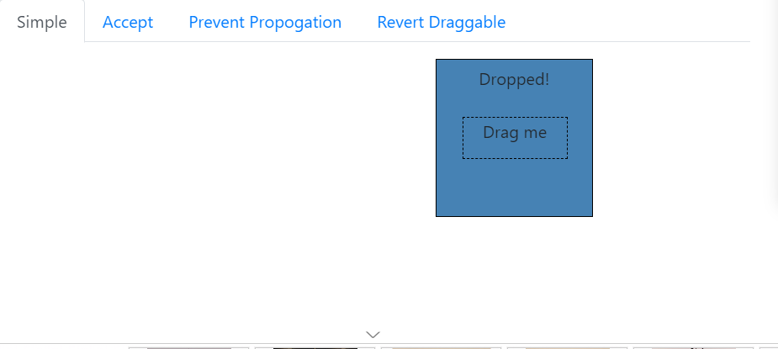

**Class Exercise 2:**

| **package com.Day5.Day5CE; import org.openqa.selenium.By; import org.openqa.selenium.WebDriver; import org.openqa.selenium.WebElement; import org.openqa.selenium.chrome.ChromeDriver; import org.openqa.selenium.chrome.ChromeOptions; import org.openqa.selenium.interactions.Actions; import io.github.bonigarcia.wdm.WebDriverManager; public class ClassExercise2 {  public static void main(String[] args) {  ChromeOptions co=new ChromeOptions();  co.addArguments("--remote-allow-origins=*");  WebDriverManager.chromedriver().setup();  WebDriver driver=new ChromeDriver(co);  driver.manage().window().maximize();  driver.navigate().to("https://jqueryui.com/droppable/");  driver.switchTo().frame(0);  WebElement drag=driver.findElement(By.id("draggable"));  WebElement drop=driver.findElement(By.id("droppable"));  Actions a=new Actions(driver);  a.dragAndDrop(drag, drop).build().perform();  } }** |
| --- |

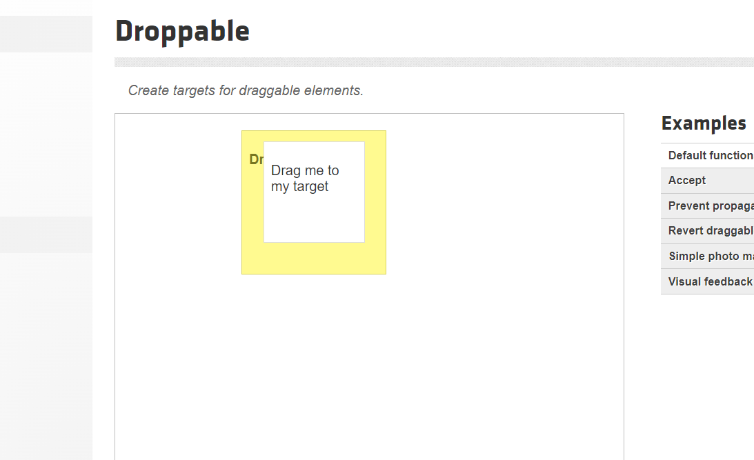

**Class Exercise 3:**

| **package com.Day5.Day5CE; import org.openqa.selenium.Alert; import org.openqa.selenium.By; import org.openqa.selenium.WebDriver; import org.openqa.selenium.WebElement; import org.openqa.selenium.chrome.ChromeDriver; import org.openqa.selenium.chrome.ChromeOptions; import io.github.bonigarcia.wdm.WebDriverManager; public class ClassExercise3 {  public static void main(String[] args) {  ChromeOptions co=new ChromeOptions();  co.addArguments("--remote-allow-origins=*");  WebDriverManager.chromedriver().setup();  WebDriver driver=new ChromeDriver(co); driver.navigate().to("https://demo.guru99.com/test/delete_customer.php");  WebElement textBox=driver.findElement(By.xpath("/html/body/form/table/tbody/tr[2]/td[2]/input"));  textBox.sendKeys("401"); driver.findElement(By.xpath("/html/body/form/table/tbody/tr[3]/td[2]/input[1]")).click();  Alert alert1=driver.switchTo().alert();  alert1.dismiss();  textBox.clear();  textBox.sendKeys("402"); driver.findElement(By.xpath("/html/body/form/table/tbody/tr[3]/td[2]/input[1]")).click();  Alert alert2=driver.switchTo().alert();  alert2.accept();  Alert alert3=driver.switchTo().alert();  String finalText=alert3.getText();  alert3.accept();  System.out.print(finalText);  } }** |
| --- |

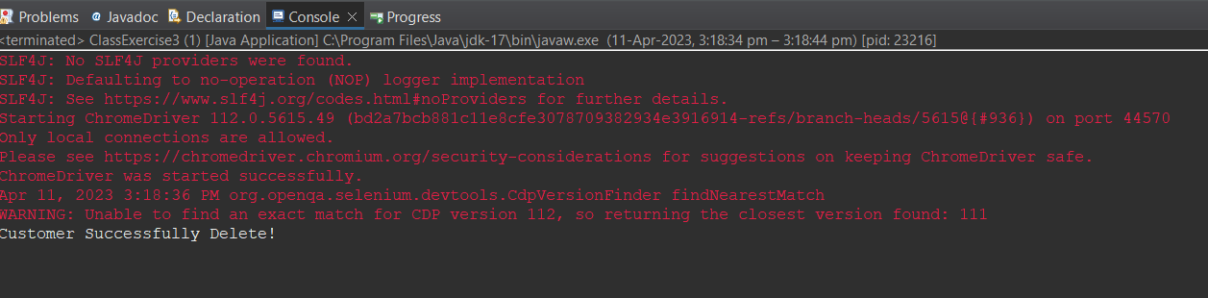

**Class Exercise 4:**

| **package com.Day5.Day5CE; import org.openqa.selenium.By; import org.openqa.selenium.WebDriver; import org.openqa.selenium.chrome.ChromeDriver; import org.openqa.selenium.chrome.ChromeOptions; import io.github.bonigarcia.wdm.WebDriverManager; public class ClassExercise4 {  public static void main(String[] args) throws InterruptedException {  ChromeOptions co=new ChromeOptions();  co.addArguments("--remote-allow-origins=*");  WebDriverManager.chromedriver().setup();  WebDriver driver=new ChromeDriver(co);  driver.navigate().to("https://www.abhibus.com/bus-ticket-booking");  driver.manage().window().maximize();  driver.findElement(By.xpath("//*[@id=\"datepicker1\"]")).click();  Thread.sleep(3000);  driver.findElement(By.xpath("//*[@id=\"ui-datepicker-div\"]/div[2]/table/tbody/tr[4]/td[3]/a")).click();  driver.findElement(By.xpath("//*[@id=\"source\"]")).sendKeys("Chennai");  driver.findElement(By.xpath("//*[@id=\"destination\"]")).sendKeys("Coimbatore");        } }** |
| --- |

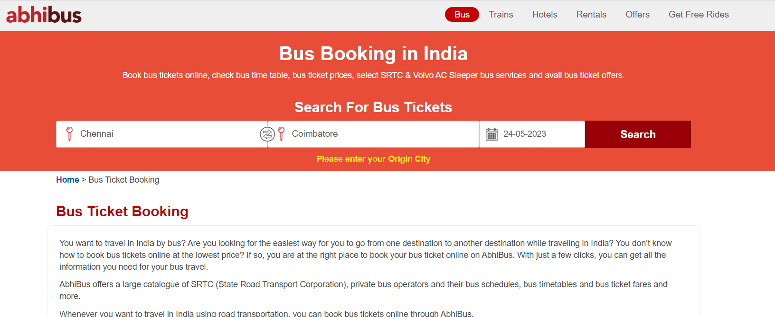

**Class Exercise 5:**

| **package com.Day5.Day5CE; import org.openqa.selenium.By; import org.openqa.selenium.Keys; import org.openqa.selenium.WebDriver; import org.openqa.selenium.WindowType; import org.openqa.selenium.chrome.ChromeDriver; import org.openqa.selenium.chrome.ChromeOptions; import io.github.bonigarcia.wdm.WebDriverManager; public class ClassExercise5 {  public static void main(String[] args) {  ChromeOptions co=new ChromeOptions();  co.addArguments("--remote-allow-origins=*");  WebDriverManager.chromedriver().setup();  WebDriver driver=new ChromeDriver(co);  driver.get("https://www.google.com");  driver.manage().window().maximize();  driver.findElement(By.name("q")).sendKeys("Apple");  driver.findElement(By.name("q")).sendKeys(Keys.ENTER);    System.out.println(driver.getWindowHandle());  System.out.println(driver.getTitle());  System.out.println();    driver.switchTo().newWindow(WindowType.TAB);  driver.get("https://www.google.com");  driver.manage().window().maximize();  driver.findElement(By.name("q")).sendKeys("Selenium");  driver.findElement(By.name("q")).sendKeys(Keys.ENTER);    System.out.println(driver.getWindowHandle());  System.out.println(driver.getTitle());  System.out.println();    driver.switchTo().newWindow(WindowType.TAB);  driver.get("https://www.google.com");  driver.manage().window().maximize();  driver.findElement(By.name("q")).sendKeys("Cucumber");  driver.findElement(By.name("q")).sendKeys(Keys.ENTER);    System.out.println(driver.getWindowHandle());  System.out.println(driver.getTitle());  System.out.println();      } }** |
| --- |

